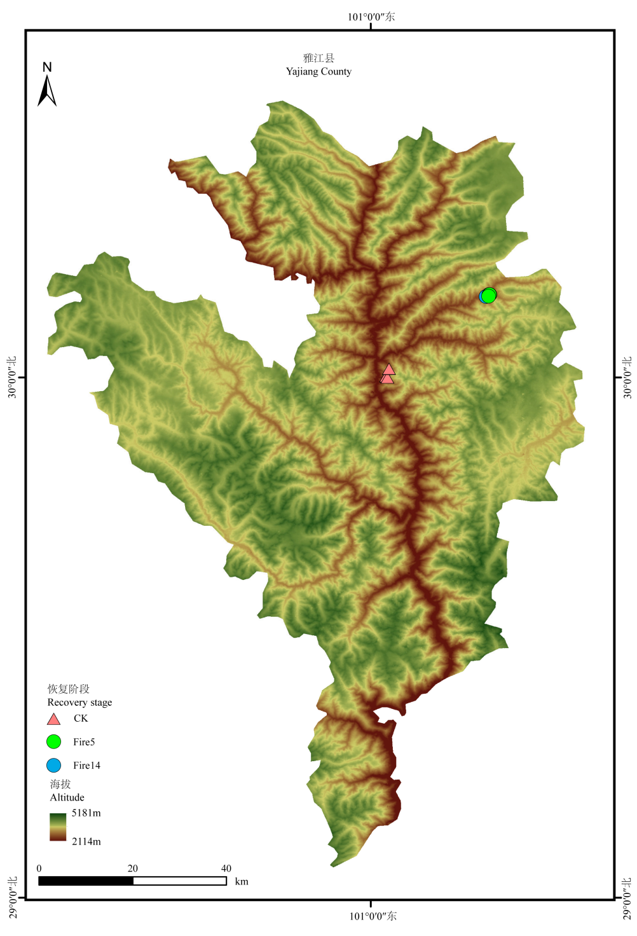
附录1 雅江县火干扰及对照样地分布图。CK：未受火干扰；Fire5：火干扰后5年；Fire14：火干扰后14年。
Appendix 1 Distribution map of fire disturbance and control plots in Yajiang County. CK: Unburned; Fire5: 5 years post-fire; Fire14: 14 years post-fire.

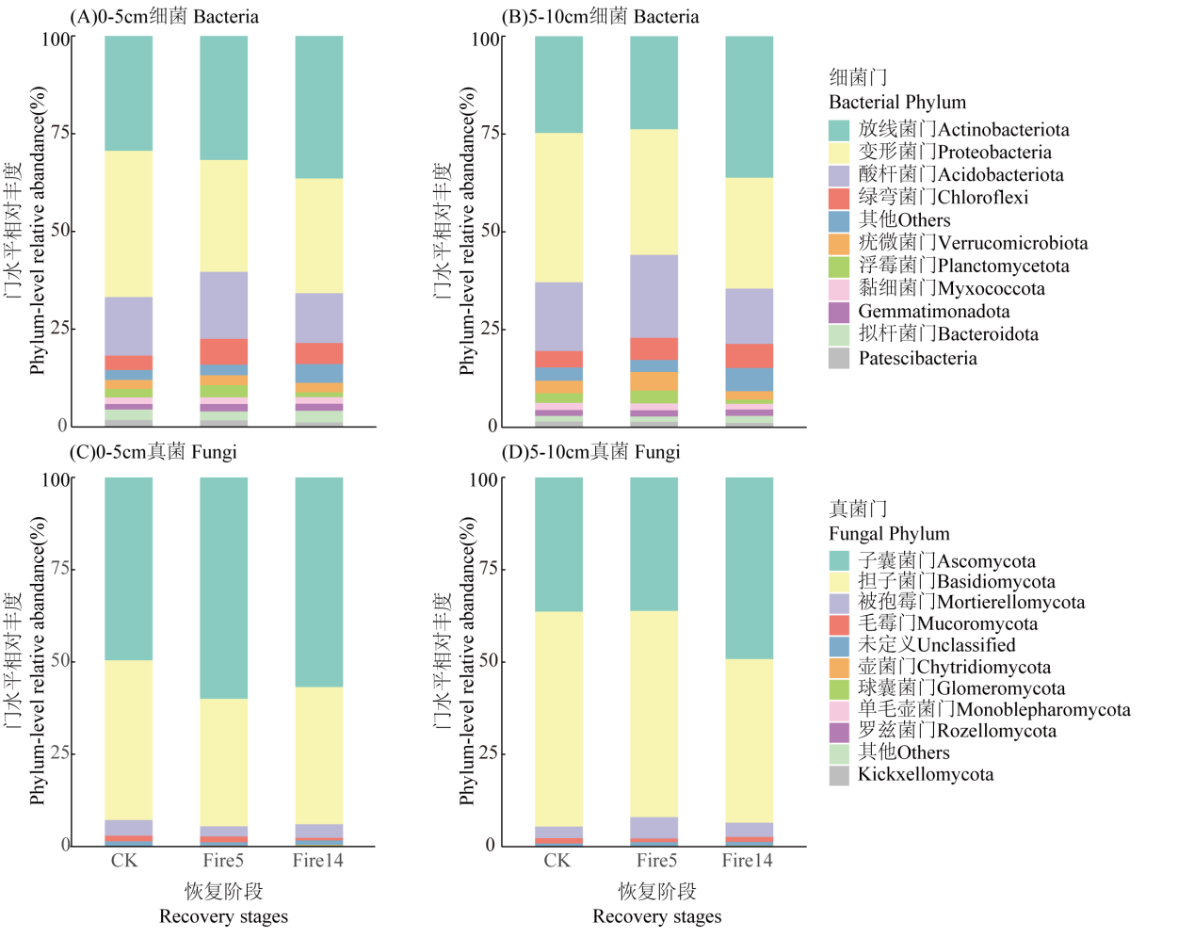
附录2 不同恢复阶段土壤微生物优势菌门的相对丰度。(A) 0-5 cm细菌；(B)5-10 cm细菌；(C) 0-5 cm真菌；(D) 5-10 cm真菌。CK：未受火干扰；Fire5：火干扰后5年；Fire14：火干扰后14年。
Appendix 2 Relative abundance of dominant phyla of soil microorganisms at different recovery stages. (A) 0-5 cm Bacteria; (B) 5-10 cm Bacteria; (C) 0-5 cm Fungi; (D) 5-10 cm Fungi. CK: Unburned; Fire5: 5 years post-fire; Fire14: 14 years post-fire.

附录3 火干扰后恢复阶段和土层对土壤微生物群落结构影响的双因素PERMANOVA检验
Appendix 3 Two-way PERMANOVA test of the effects of recovery stage after fire disturbance and soil layer on soil microbial community structure
微生物Microorganism | 因素Factor | R2 | P
细菌  Bacteria | 土层 Soil layer | 0.071 | 0.020
细菌  Bacteria | 恢复阶段 recovery stage | 0.347 | 0.001
细菌  Bacteria | 土层 × 恢复阶段 Soil layer × recovery stage | 0.043 | 0.779
真菌  Fungi | 土层 Soil layer | 0.042 | 0.397
真菌  Fungi | 恢复阶段 Recovery stage | 0.200 | 0.001
真菌  Fungi | 土层 × 恢复阶段 Soil layer × recovery stage | 0.030 | 1.000

附录4 火干扰后不同恢复阶段的土层对微生物群落结构影响的PERMANOVA检验
Appendix 4 PERMANOVA test of the impact of soil layers on microbial community structure at different recovery stages after fire disturbance
微生物  Microorganism | CK |  | Fire5 |  | Fire14
微生物  Microorganism | R² | P | R² | P | R² | P
细菌Bacteria | 0.114 | 0.164 | 0.362 | 0.1 | 0.119 | 0.8
真菌Fungi | 0.056 | 0.854 | 0.222 | 0.5 | 0.056 | 0.7
CK：未受火干扰；Fire5：火干扰后5年；Fire14：火干扰后14年。
CK: Unburned; Fire5: 5 years post-fire; Fire14: 14 years post-fire.

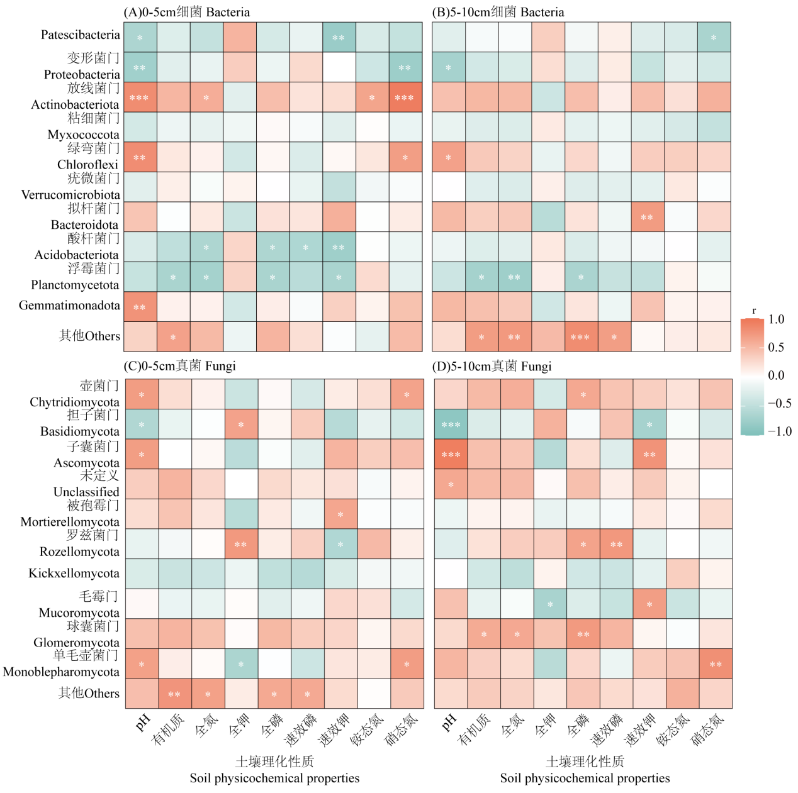
附录5 土壤微生物优势菌门和土壤理化性质的相关性分析。(A) 0-5 cm细菌；(B) 5-10 cm细菌；(C) 0-5 cm真菌；(D) 5-10 cm真菌。* P < 0.05；** P < 0.01；*** P < 0.001。
Appendix 5 Correlation analysis between dominant phyla of soil microorganisms and soil physicochemical properties. (A) 0-5 cm Bacteria; (B) 5-10 cm Bacteria; (C) 0-5 cm Fungi; (D) 5-10 cm Fungi. * P < 0.05; ** P < 0.01; *** P < 0.001.

